**Understanding Cinema Market Forces and their Role in the**

**Changing Bahamian Theater Landscape**

A lingering question has been posed concerning the expedience with which the Showcase with IMAX will position itself as the industry leader in the Bahamas. How can the same remove Galleria Cinemas from the marketplace, without a protracted battle?

To comprehend how this elimination will be done requires an understanding of three elements of the market:

* The Movie Life Cycle
* Theater Industry Seasonal Cycle
* The Effects of Premium Brands on both of these cycles

However, looking back at a historically similar situation can shed light on future endeavors.

**RND Cinemas vs Galleria Cinemas** (1999-2004)

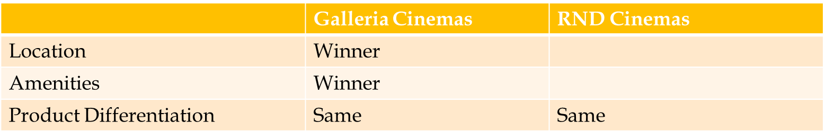Why did Galleria Cinemas take five years to close out RND Cinemas from the Bahamian cinema market? Discounting managerial decisions of the aforementioned companies and focusing on choices the customer base had, a clearer portrait emerges.

Galleria Cinemas’ Mall location and new build provided distinct advantages that separated it from its competitor. When you combine that with the fact that there was no difference in the movie product the consumer would see, RND Cinemas was doomed.

However, the pendulum swung both ways. Though most consumers chose Galleria, that lack of product differentiation also allowed RND to stay viable for years through numerous promotions. Customers couldn’t see a difference.

The landscape of the Bahamian Theater industry, a decade later, is different now. Yet the customer base, though younger, is still similar. People still need to see product differentiation to avoid the repeat of a defeated yet lingering opponent.

**The Showcase with IMAX vs Galleria Cinemas (2014)**

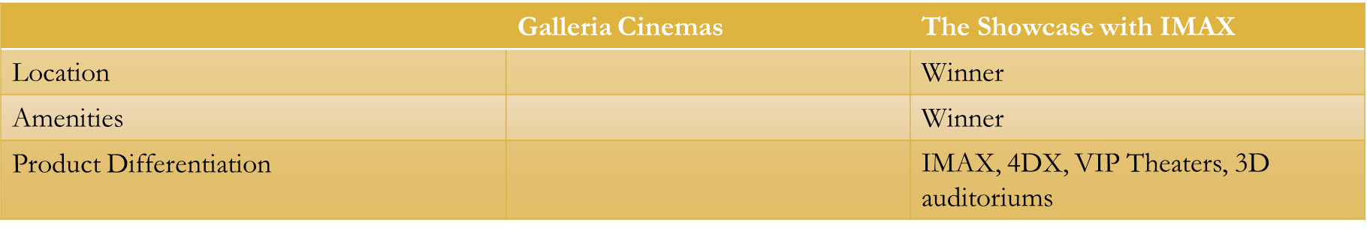Examining the differences between Galleria Cinemas and The Showcase with IMAX reveals a completely different story for the current market leader.

Besides location and amenities (Lounge, Arcade, Party Rooms), The Showcase will provide consumers four definitive experiences that they currently cannot get at Galleria. Besides the 3D and VIP auditoriums, 4DX and IMAX have built in industry component that preclude the repeat of history with Galleria and RND.

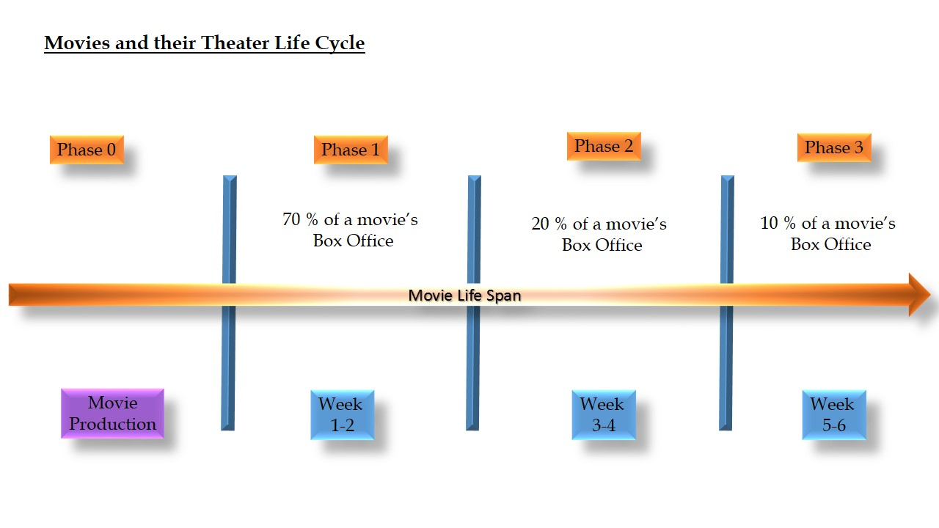Understanding a movie’s life cycle unwraps part of the intrinsic advantages of the 4DX and IMAX.

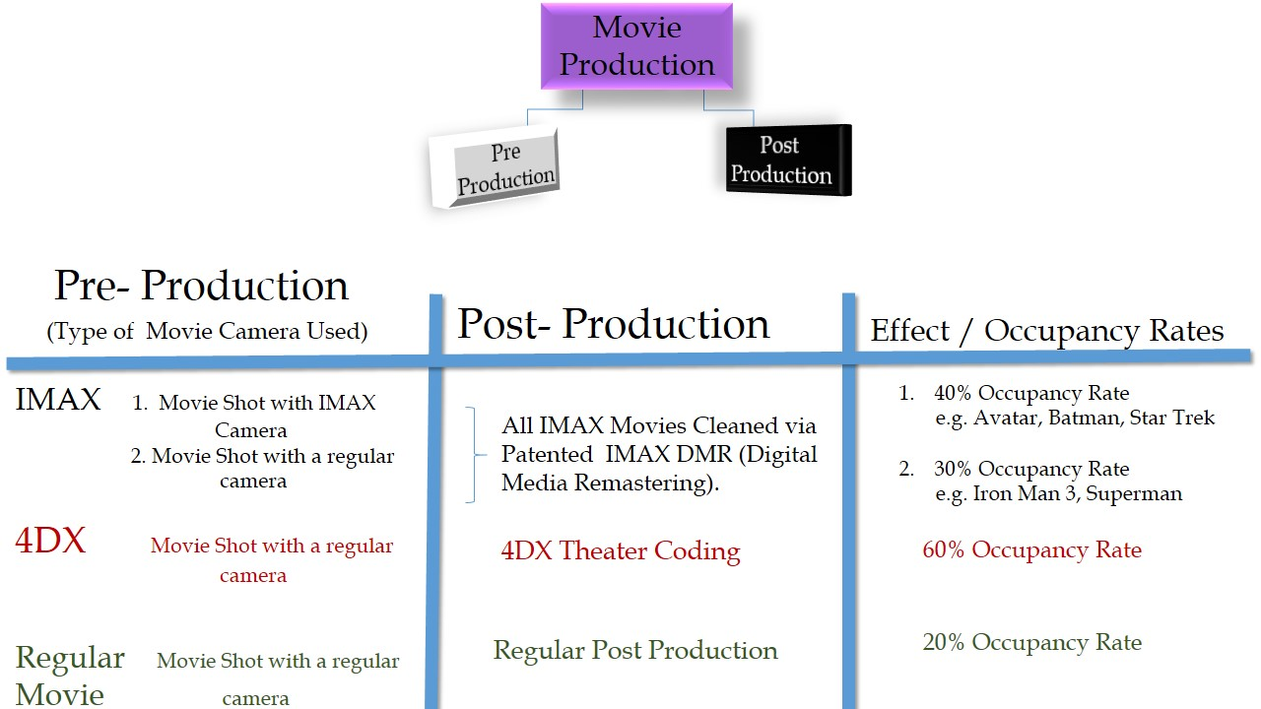

Partly due to the work done by 4DX/IMAX in pre and post production of movies, these premium brands enjoy a higher occupancy rate than regular movie theaters. When combining that high occupancy rate with 4DX and IMAX limited engagement policy, a potent combination reveals itself.

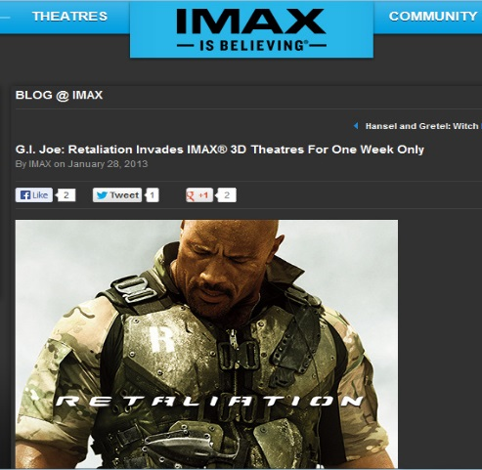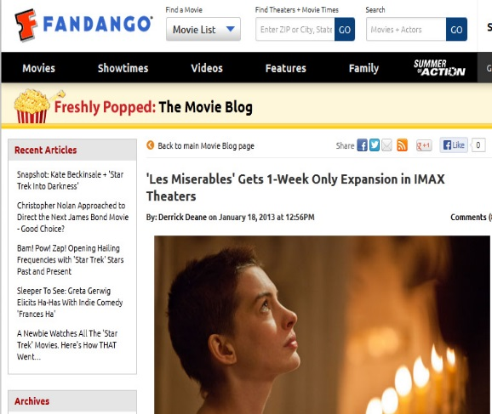IMAX and 4DX movies are only available for the first week or two of a movie.

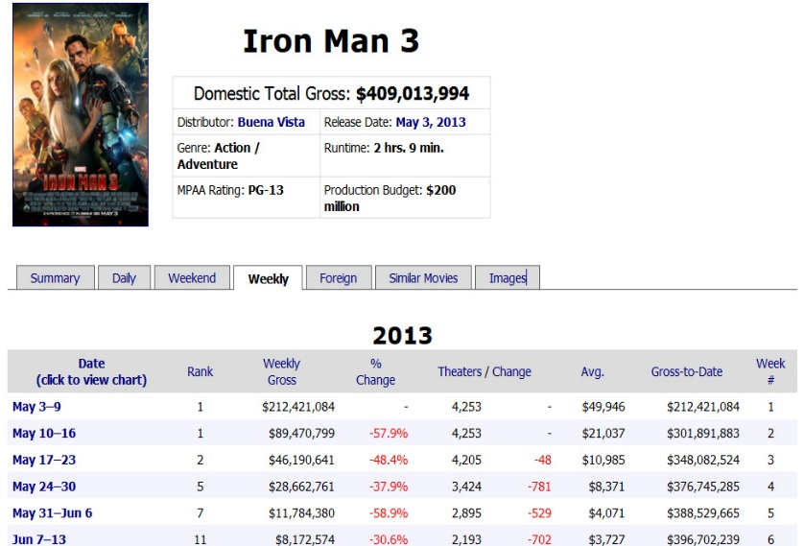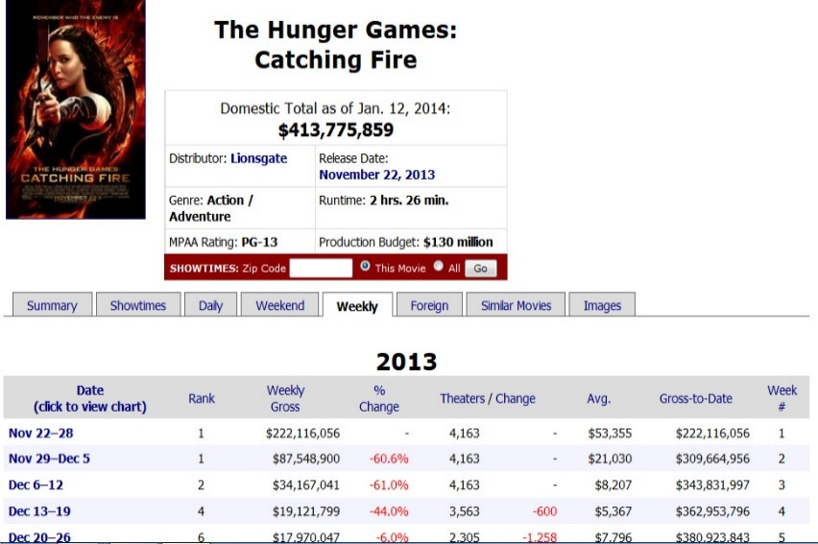A movie makes 70% of its total box office during those first two weeks.

Of that amount, IMAX and 4DX take the lion’s share of a market’s box office totals.

C:\Users\User\Desktop\hunger games.jpg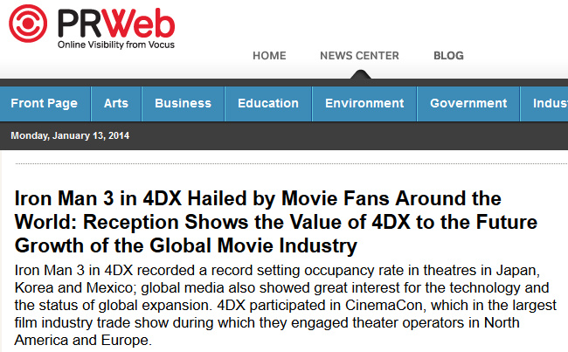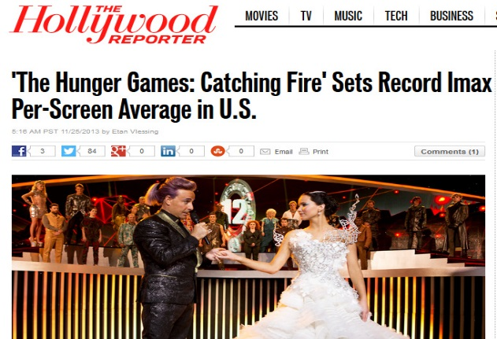

This premium strategy has important residual effects for a multiplex with exclusive rights:

* These short one and two week movie engagements for 4DX and IMAX (vs the traditional 6 week engagements of regular movies) drive a continuous new rush into these multiplexes with patrons hoping to get a seat.
* 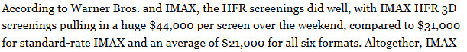C:\Users\User\Desktop\Fullscreen capture 1152014 25014 AM.bmp.jpg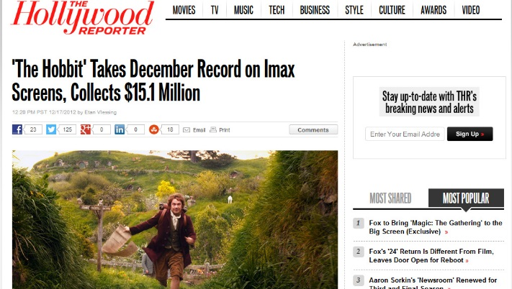An industry phenomenon called ‘The Spill-Over Effect’ occurs. Customers that did not get a ticket for the show they wanted purchases a ticket for the next day and also buy a ticket for another movie to watch that day. Hence IMAX and 4DX drive customers to regular digital screen in these multiplexes.

This Spill-Over Effect was chronicled in a global study conducted by IMAX. The Atavus Group asked IMAX global to provide data about this residual effect but within the parameters of markets with similar size and constitution.

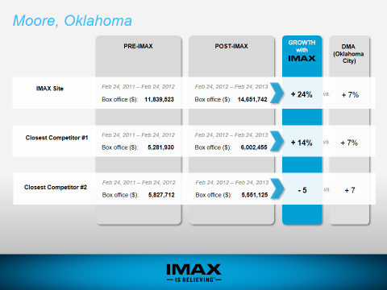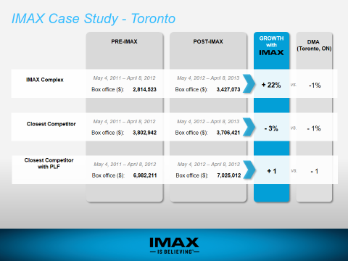Note the pre-IMAX revenue for the facilities vs the Post IMAX revenue.

This industry phenomenon is even more important when you look at the Designated Market Area (DMA). DMA represents the competitive landscape and its effects on customers and competitors in a specific area. In the case of Moore, DMA grew because they drove traffic into the area. However in suburbs of Toronto, DMA decrease because they drove a competitor out of business.

From an industry wide perspective, this has wide ranging consequences. The Cinema business is a Feast or Famine Industry.

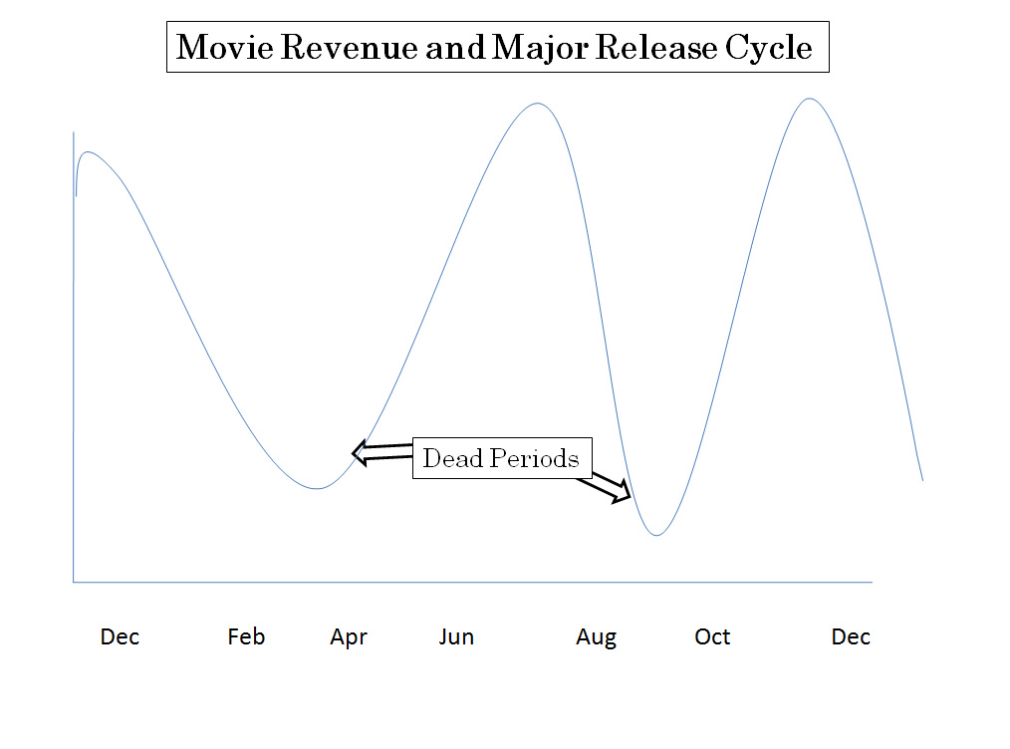Theater Owners use the profits from the summer and holiday blockbuster seasons to stay afloat during the dead periods. Looking at the top 25 Movies for 2012 and 2013 shows the true power of premium brands and their effect on theater ownership.

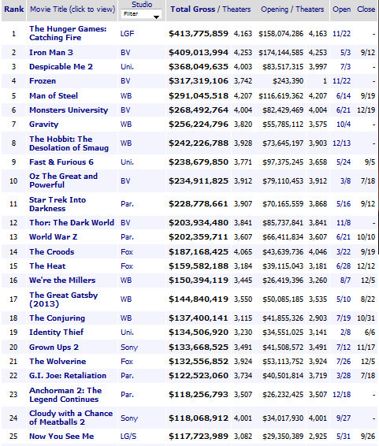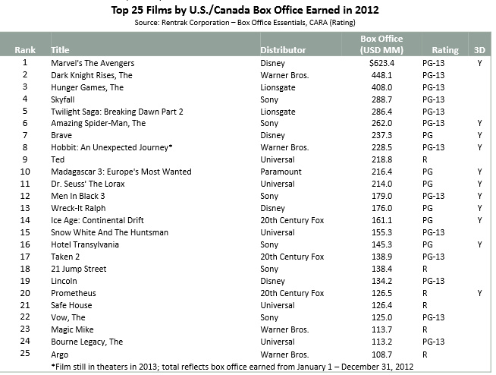 2012 Box Office Top 25 2013 Box Office Top 25

In 2012

* The top 25 movies or 3.8% of movies made in 2012 represented 53% of total industry revenue.
* 9 of the top 15 and 15 of those 25 were in 4DX/IMAX formats.

In 2013:

The effects of the Premium Brands were even **more** pronounced

* The top 25 movies or 3.7% of movies made in 2013 represented 52% of total industry revenue.
* 14 of the top 15 and 19 of top 25 were in 4DX/IMAX formats.

Therefore by dominating the important first two weeks of a movie and the top 25, IMAX and 4DX are determining regional box office control.

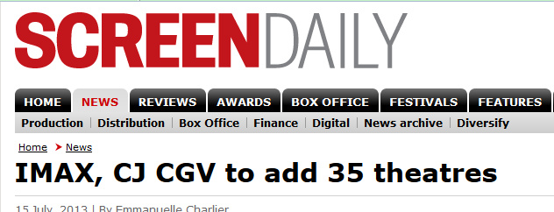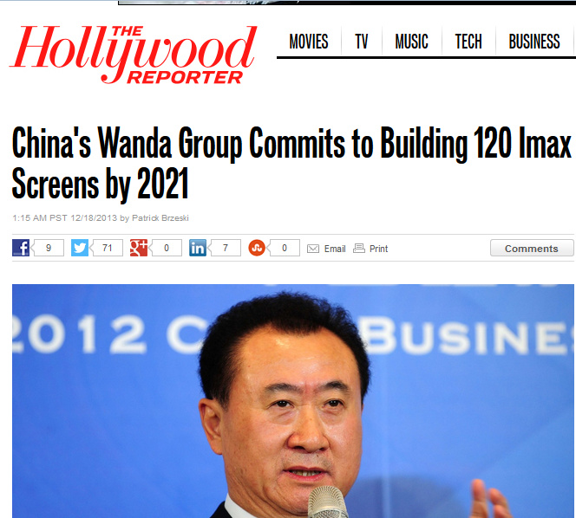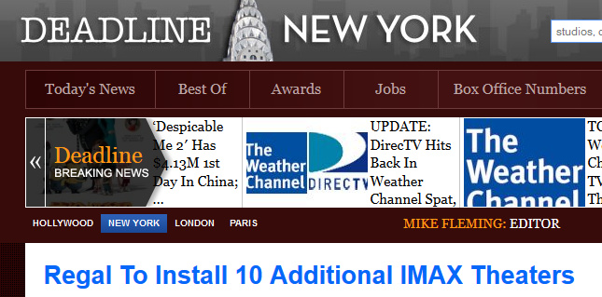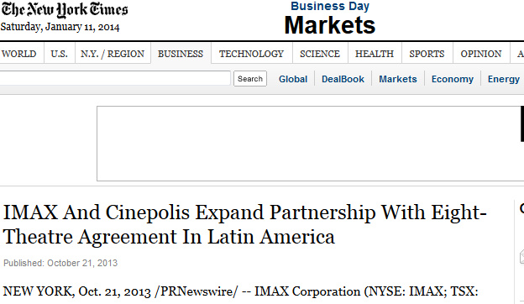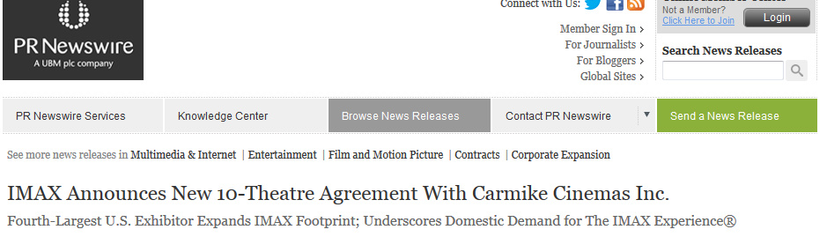This is why the top 6 Global Movie Chains (AMC/Wanda, Regal, CJCGV, Cinepolis, and Carmike) are fighting to secure IMAX licenses in key areas and cities.

This becomes paramount in a limited fragile market like the Bahamas. Three (3) major consequences will occur:

* Controlling the blockbuster seasons via 4DX and IMAX determines the sustainability of all.
* Adding that amalgam to the VIP theaters and true 3D content in the regular theaters, will allow The Showcase to **differentiate** itself in the minds of consumers.
* The capital needed from the ‘feast ‘season, for Galleria to remain viable, will be curtailed dramatically.

**Managing the ‘Spill-Over’ Effects from the Premium Brands**

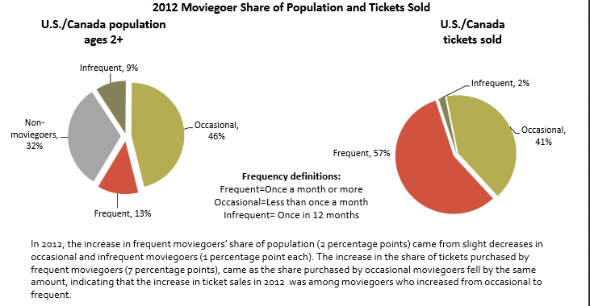Managing customers’ needs first requires an understanding of who they are. According to the Motion Picture Association of America (MPAA), 13 % (frequent mover goers) of a population drives almost 60% of your business.

Surveys have shown that frequent moviegoers prefer the premium experiences like IMAX or 4DX.The other 40% of your ticket sales will be driven by Occasional movie goers. Reaching this segment of the market is the true battle ground.

Strategy: ‘Give the people what they came for – ENTERTAINMENT’

1. **The Frequent Movie Goer**

As mentioned earlier, IMAX and 4DX are the preferred entertainment experience.

1. 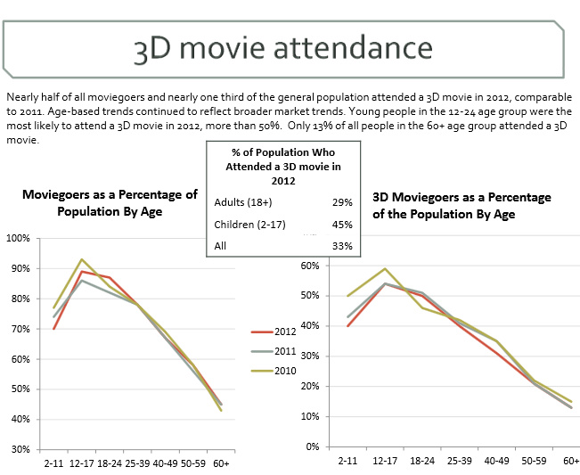**The Parent wanting Value for the Kids experience**

Bring back true 3D for the kids and young adult market.

This segment of the market has been shown statistically, a willingness to pay for the product. However, the value of the experience has been lacking hence customer frustration.

1. **The Price Tolerant, Non Movie Goer**

* The VIP Theaters, with their regular & alternative content like the Opera, is an ideal value.
* IMAX Educational documentaries are world renowned for their cultural enhancement and beauty. These non-movie goers will love the thought-provoking content that’s not found in regular cinema.

1. **The Price Conscious Movie Goer**

* Individuals can go to one of the Showcase’s regular digital screens that is priced at the same rate as the competition.
* The Sponsorship program will be invaluable in reaching this segment of the market through cross promotions that target these bargain hunters.
* 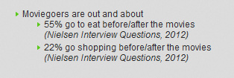Provide unmatched value to this segment. How? Research and Preparation. For Example:

Value is consumer specific. Realizing that 55% of the market eats before and after movies mandate that a full lounge exist on the premises. Providing services and amenities such as this adds worth to the jaded cost-conscious consumer. This all-in-one experience saves them time and money, while building brand loyalty.

1. **Reaching The Tourist Market**
2. 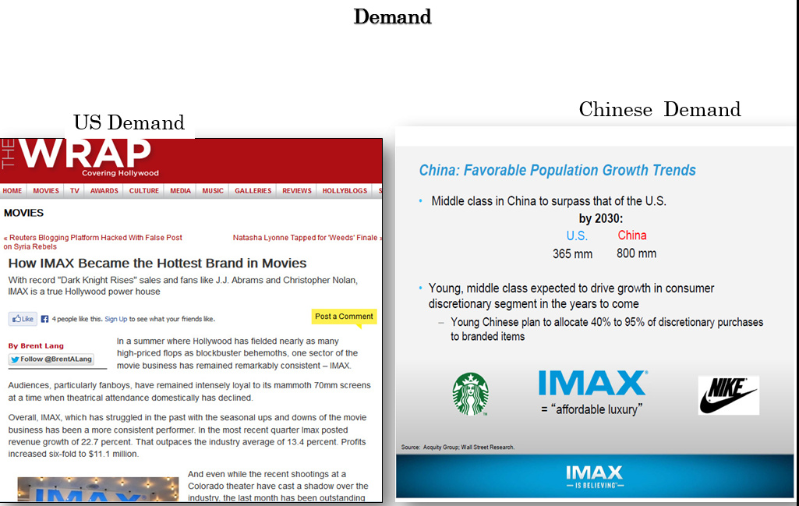Understanding that there is a demand for IMAX and 4DX in this market is key.
3. Why will the tourists come? Can they just wait until they get home? The Answer is **NO!**

The Average US/Canadian Vacation is 5.4 days. The average Asian Vacation is 2/3 weeks. IMAX engagements usually last a week maybe two. Hence by the time they return home the movie is out of their preferred format.

The Bahamian Market, with its diverse influences, is ever changing. Galleria Cinemas for whatever reason, has not kept up with consumer demands or industry innovations. The same can react in many ways to the Showcase’s market entrance. However, it is this inherent reactive nature that will be its undoing. Innovation and proactive management is needed in the face of a volatile economy and jaded consumer base.

The beauty of ‘The Showcase with IMAX’ is in its fundamental design and strategy:

STRENGTH to STRENGTH

* Market Leading, Premium Brands for Differentiation
* World Class Designed Facilities and Amenities
* On Point Customer Service through continual training and incentives
* Innovative and Flexible Management with extensive corporate support
* Price Sensitivity while providing Value to the Consumer Experience
* Financial Control of the Blockbuster Seasons determining market viability

These six tenants will be the pillars upon which ‘The Showcase with IMAX’ will stand.